|  |
| --- |
| **Ex No. 03 Write an application that draws Basic Graphical Primitives on the screen**  **Date:** |

**Aim:**

To develop a Simple Android Application that draws basic Graphical Primitives on the screen. **Procedure:**

**Creating a New project:**

∙ Open Android Studio and then click on **File -> New -> New project**.

∙ Then type the Application name as **“exno3″** and click Next.

∙ Then **select the Minimum SDK** as shown below and click Next.

∙ Then **select the Empty Act**ivity and click Next.

∙ Finally click **Finish**.

∙ It will take some time to build and load the project.

∙ After completion it will look as given below.

**Designing layout for the Android Application:**

∙ Click on **app -> res -> layout -> activity_main.xml**.

∙ Now click on Text as shown below.

∙ Then delete the code which is there and type the code as given below.

**Code for Activity_main.xml:**

<?xml version="1.0" encoding="utf-8"?>

<RelativeLayout xmlns:android="http://schemas.android.com/apk/res/android"

android:layout_width="match_parent"

android:layout_height="match_parent">

<ImageView

android:layout_width="match_parent"

android:layout_height="match_parent"

android:id="@+id/imageView" />

</RelativeLayout>

∙ Now click on Design and your application will look as given below.

∙ So now the designing part is completed.

**Java Coding for the Android Application:**

∙ Click on **app -> java -> com.example.exno3 -> MainActivity**.

∙ Then delete the code which is there and type the code as given below.

**Code for MainActivity.java:**

package com.example.exno3;

import android.app.Activity;

import android.graphics.Bitmap;

import android.graphics.Canvas;

import android.graphics.Color;

import android.graphics.Paint;

import android.graphics.drawable.BitmapDrawable;

import android.os.Bundle;

import android.widget.ImageView;

public class MainActivity extends Activity

{

@Override

public void onCreate(Bundle savedInstanceState)

{

super.onCreate(savedInstanceState);

setContentView(R.layout.activity_main);

Bitmap bg = Bitmap.createBitmap(720, 1280, Bitmap.Config.ARGB_8888);

ImageView i = (ImageView) findViewById(R.id.imageView); i.setBackgroundDrawable(new BitmapDrawable(bg));

Canvas canvas = new Canvas(bg);

Paint paint = new Paint();

paint.setColor(Color.BLUE);

paint.setTextSize(50);

canvas.drawText("Rectangle", 420, 150, paint);

canvas.drawRect(400, 200, 650, 700, paint);

canvas.drawText("Circle", 120, 150, paint);

canvas.drawCircle(200, 350, 150, paint);

canvas.drawText("Square", 120, 800, paint);

canvas.drawRect(50, 850, 350, 1150, paint);

canvas.drawText("Line", 480, 800, paint);

canvas.drawLine(520, 850, 520, 1150, paint);

}

}

**Output:**

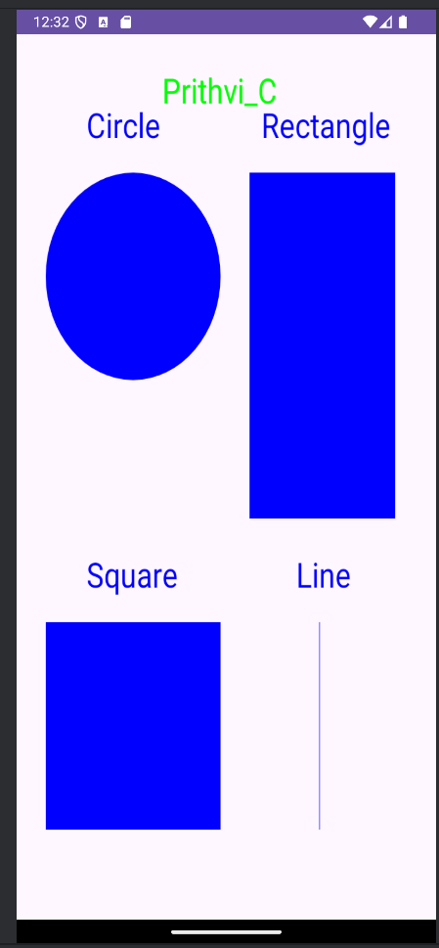

**Result:**

Thus a Simple Android Application that draws basic Graphical Primitives on the screen is developed and executed successfully.

|  |
| --- |
| **Ex. No. 04 Develop an application that makes use of database**  **Date:** |

**Aim:**

To develop a Simple Android Application that makes use of Database.

**Procedure:**

**Creating a New project:**

∙ Open Android Studio and then click on **File -> New -> New project**.

∙ Then type the Application name as **“exno4″** and click Next.

∙ Then **select the Minimum S**DK as shown below and click Next.

∙ Then **select the Empty Activity** and click Next.

∙ Finally click **Finish**.

∙ It will take some time to build and load the project.

∙ After completion it will look as given below.

**Designing layout for the Android Application:**

∙ Click on **app -> res -> layout -> activity_main.xml**.

∙ Now click on Text as shown below.

∙ Then delete the code which is there and type the code as given below.

**Code for Activity_main.xml:**

<?xml version="1.0" encoding="utf-8"?>

<AbsoluteLayout xmlns:android="http://schemas.android.com/apk/res/android"

android:layout_width="match_parent"

android:layout_height="match_parent">

<TextView

android:layout_width="wrap_content"

android:layout_height="wrap_content"

android:layout_x="50dp"

android:layout_y="20dp"

android:text="Student Details"

android:textSize="30sp" />

<TextView

android:layout_width="wrap_content"

android:layout_height="wrap_content"

android:layout_x="20dp"

android:layout_y="110dp"

android:text="Enter Rollno:"

android:textSize="20sp" />

<EditText

android:id="@+id/Rollno"

android:layout_width="150dp" android:layout_height="wrap_content" android:layout_x="175dp"

android:layout_y="100dp"

android:inputType="number" android:textSize="20sp" />

<TextView

android:layout_width="wrap_content" android:layout_height="wrap_content" android:layout_x="20dp"

android:layout_y="160dp"

android:text="Enter Name:"

android:textSize="20sp" />

<EditText

android:id="@+id/Name"

android:layout_width="150dp" android:layout_height="wrap_content" android:layout_x="175dp"

android:layout_y="150dp"

android:inputType="text"

android:textSize="20sp" />

<TextView

android:layout_width="wrap_content" android:layout_height="wrap_content" android:layout_x="20dp"

android:layout_y="210dp"

android:text="Enter Marks:"

android:textSize="20sp" />

<EditText

android:id="@+id/Marks"

android:layout_width="150dp" android:layout_height="wrap_content"

android:layout_x="175dp"

android:layout_y="200dp"

android:inputType="number" android:textSize="20sp" />

<Button

android:id="@+id/Insert"

android:layout_width="150dp" android:layout_height="wrap_content" android:layout_x="25dp"

android:layout_y="300dp"

android:text="Insert"

android:textSize="30dp" />

<Button

android:id="@+id/Delete"

android:layout_width="150dp" android:layout_height="wrap_content" android:layout_x="200dp"

android:layout_y="300dp"

android:text="Delete"

android:textSize="30dp" />

<Button

android:id="@+id/Update"

android:layout_width="150dp" android:layout_height="wrap_content" android:layout_x="25dp"

android:layout_y="400dp"

android:text="Update"

android:textSize="30dp" />

<Button

android:id="@+id/View"

android:layout_width="150dp" android:layout_height="wrap_content" android:layout_x="200dp"

android:layout_y="400dp"

android:text="View"

android:textSize="30dp" />

<Button

android:id="@+id/ViewAll"

android:layout_width="200dp"

android:layout_height="wrap_content"

android:layout_x="100dp"

android:layout_y="500dp"

android:text="View All"

android:textSize="30dp" />

</AbsoluteLayout>

**Java Coding for the Android Application:**

∙ Click on **app -> java -> com.example.exno4 -> MainActivity**. ∙ Then delete the code which is there and type the code as given below. **Code for MainActivity.java:**

packagecom.example.exno4;

import android.app.Activity;

import android.app.AlertDialog.Builder;

import android.content.Context;

import android.database.Cursor;

import android.database.sqlite.SQLiteDatabase;

import android.os.Bundle;

import android.view.View;

import android.view.View.OnClickListener;

import android.widget.Button;

import android.widget.EditText;

public class MainActivity extends Activity implements OnClickListener {

EditText Rollno,Name,Marks;

Button Insert,Delete,Update,View,ViewAll;

SQLiteDatabase db;

@Override

public void onCreate(Bundle savedInstanceState)

{

super.onCreate(savedInstanceState);

setContentView(R.layout.activity_main); Rollno=(EditText)findViewById(R.id.Rollno);

Name=(EditText)findViewById(R.id.Name);

Marks=(EditText)findViewById(R.id.Marks);

Insert=(Button)findViewById(R.id.Insert);

Delete=(Button)findViewById(R.id.Delete);

Update=(Button)findViewById(R.id.Update);

View=(Button)findViewById(R.id.View);

ViewAll=(Button)findViewById(R.id.ViewAll);

Insert.setOnClickListener(this);

Delete.setOnClickListener(this);

Update.setOnClickListener(this);

View.setOnClickListener(this);

ViewAll.setOnClickListener(this);

db=openOrCreateDatabase("StudentDB", Context.MODE_PRIVATE, null); db.execSQL("CREATE TABLE IF NOT EXISTS student(rollno VARCHAR,name VARCHAR,marks VARCHAR);");

}

public void onClick(View view)

{

if(view==Insert)

{

if(Rollno.getText().toString().trim().length()==0||

Name.getText().toString().trim().length()==0||

Marks.getText().toString().trim().length()==0)

{

showMessage("Error", "Please enter all values");

return;

}

db.execSQL("INSERT INTO student VALUES('"+Rollno.getText()+"','"+Name.getText()+ "','"+Marks.getText()+"');");

showMessage("Success", "Record added");

clearText();

}

if(view==Delete)

{

if(Rollno.getText().toString().trim().length()==0)

{

showMessage("Error", "Please enter Rollno");

return;

}

Cursor c=db.rawQuery("SELECT * FROM student WHERE rollno='"+Rollno.getText()+"'", null); if(c.moveToFirst())

{

db.execSQL("DELETE FROM student WHERE rollno='"+Rollno.getText()+"'"); showMessage("Success", "Record Deleted");

}

else

{

showMessage("Error", "Invalid Rollno");

}

clearText();

}

if(view==Update)

{

if(Rollno.getText().toString().trim().length()==0)

{

showMessage("Error", "Please enter Rollno");

return;

}

Cursor c=db.rawQuery("SELECT * FROM student WHERE rollno='"+Rollno.getText()+"'", null); if(c.moveToFirst()) {

db.execSQL("UPDATE student SET name='" + Name.getText() + "',marks='" + Marks.getText() + "' WHERE rollno='"+Rollno.getText()+"'");

showMessage("Success", "Record Modified");

}

else {

showMessage("Error", "Invalid Rollno");

}

clearText();

}

if(view==View)

{

if(Rollno.getText().toString().trim().length()==0)

{

showMessage("Error", "Please enter Rollno");

return;

}

Cursor c=db.rawQuery("SELECT * FROM student WHERE rollno='"+Rollno.getText()+"'", null); if(c.moveToFirst())

{

Name.setText(c.getString(1));

Marks.setText(c.getString(2));

}

else

{

showMessage("Error", "Invalid Rollno");

clearText();

}

}

if(view==ViewAll)

{

Cursor c=db.rawQuery("SELECT * FROM student", null);

if(c.getCount()==0)

{

showMessage("Error", "No records found");

return;

}

StringBuffer buffer=new StringBuffer();

while(c.moveToNext())

{

buffer.append("Rollno: "+c.getString(0)+"\n");

buffer.append("Name: "+c.getString(1)+"\n");

buffer.append("Marks: "+c.getString(2)+"\n\n");

}

showMessage("Student Details", buffer.toString());

}

}

public void showMessage(String title,String message)

{

Builder builder=new Builder(this);

builder.setCancelable(true);

builder.setTitle(title);

builder.setMessage(message);

builder.show();

}

public void clearText()

{

Rollno.setText("");

Name.setText("");

Marks.setText("");

Rollno.requestFocus();

}

}

**Output:**

**Result:**

Thus a Simple Android Application that makes use of Database is developed and executed successfully